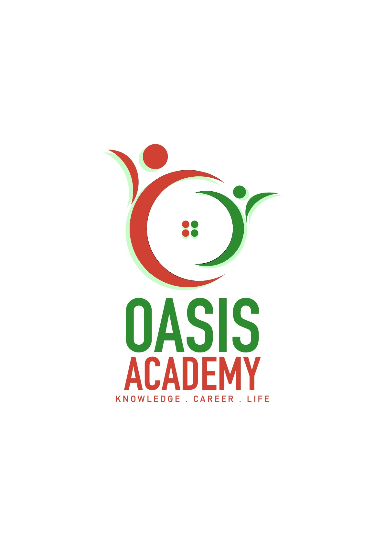

Name: Chee Fui Hlung

Login ID: cheefui@oasis-portal.com

Course title: Essentials of Marketing and Customer

Relationship

Subject Code: BHM02

Submitted date:

**Table of Contents**

|  |  |  |
| --- | --- | --- |
| **No** | **Details** | **Page** |
| 1 | Executive Summary | 2 |
| 2 | Introduction | 3 |
| 3 | Assignment Question |  |
|  | Part 1 | 4-6 |
|  | Part 2 | 7-10 |
|  | Part 3 | 11-13 |
|  | Part 4 | 14-15 |
| 4 | Conclusion | 16 |
| 5 | References | 17 |

**Executive Summary**

In this assignment I will be explaining about essentials of marketing and customer relationship. In the first part, I will briefly explain about the hospitality and the importance of hospitality in marketing. In the second part, I will explain the difference between marketing and customer service. And I will also explain the ethics of marketing and customer service. Furthermore, I will describe about the Marketing strategies and how you can apply your studies in the Hospitality Management. Lastly, I will explain in detail on the customer service skills and characteristics. And also explain the importance of hospitality customer services.

**Introduction**

What is marketing? Marketing are activities of a company associated with buying and selling a product or service. It includes advertising, selling and delivering products to people. Those people who work in marketing departments of companies try to get the attention of target.

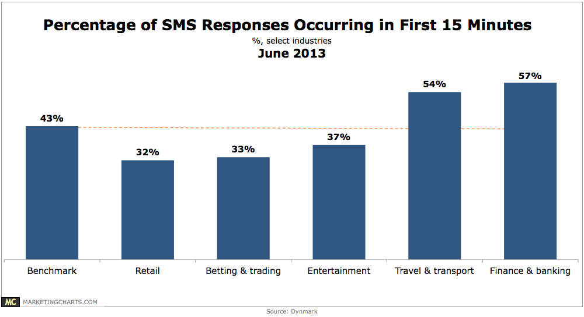

From the chart above, this is the results of advertisement in social media in June 2013

**Assignment Questions**

Question 1 : Briefly explain about Marketing in Hospitality and The importance of Hospitality Marketing.

In any business, a solid exhibiting technique is essential to building a brand, attracting new customers and caring for devotion. The friendliness business is the same. Since customer unwavering quality is indispensable, advancing managers and authorities submit a huge amount of time and resources for building brand care and making constant, interconnected campaigns. These exhibiting tries typically fuse both print and mechanized protection that goal past guests while in like manner pulling in new clients. Regardless, this particular industry has a fascinating game plan of challenges that must be overcome. Understanding the essentialness of advancing in the settlement business can empower you to exceed expectations and rise in the forceful work publicize.

Friendliness bargains are not exactly the same as purchaser stock arrangements since publicists must offer generous and also irrelevant things. A great part of the time this infers they are displaying organizations instead of items, and accomplishment relies upon making the right feeling in the buyer. For example, a resort should build up a loosening up, fun air that is unmistakable to customers and rouses those same feelings in the purchaser. Since the warmth business is generally involved tourism and other experiential organizations, a dependable brand character is furthermore basic. Publicists need to ensure that brand affirmation exists with the objective that customers will use their organizations again and again. Repeat customers obtain a sizeable portion of salary, so exhibiting approach must be part between keeping up relationship with past customers while looking out new ones.

Associations in the convenience business use diverse methods to make and keep up a suitable advancing arrangement. The going with are a part of the general frameworks that promoters use for check accomplishment. Customers pick hotels and different neighborliness organizations for a grouping of reasons. From range to workplaces and favorable circumstances, associations must ensure that they're giving what buyers are looking to. The piece of promoters is to perceive what factors make customers pick a particular settlement organization, and this requires wide research. By tending to present and past guests, watching customer reviews on destinations, investigating industry data and that is recently the starting, publicizing specialists acknowledge what makes a convenience advantage develop, and furthermore how it can be made progress.

If potential customers don't consider an organization, they can't get it. That is the place check care comes in. Publicists guarantee information on hotels, resorts and restaurants is definitely not hard to find and exceptional. They can do this by buying notice space on material travel goals, making an attracting site and cooperating with other, noncompeting sincerity benefits in a comparative market.

Another quick strategy for pulling in customers is to run progressions in the midst of particular conditions of the year, generally when business is slower. Introducing rousing strengths and offering inspirations are as of late a bit of the ways that exhibiting specialists finish this. Have you acquired a Groupon for a spa end of the week? That is progression at work.

To ensure hoisted measures of repeat business, incredible customer associations are basic. Not solely do reiterate customers usually propel an organization through verbal trade and internet organizing, notwithstanding they moreover make a consistent salary base. One way to deal with fabricate associations is through customer unwavering quality projects, which compensate customers who routinely use a particular kind disposition advantage.

Question 2:

Explain the difference between Marketing VS. Customer Service

The customer advantage and the promoting departments of an association are typically two unmistakable and by and large extraordinary workplaces. In any case, clever associations are understanding that nowadays of electronic interpersonal interaction and online reviews that customer organization and advancing go as an indistinguishable unit. It is basic for relationship to change the methodologies of old and have advancing and customer advantage coordinate, as each division can make the other's work less requesting and fulfill targets snappier. When exhibiting and customer advantage bunches collaborate, it comprehends one of the entrenched issues of customer advantage being oblivious to the one of a kind headways that the advancing gathering advances. Meanwhile it furthermore deals with another issue that happens today, when poor customer advantage achieves an issue for the web based systems administration advancing division of the workplace. Today, we will inspect some customer advantage techniques and systems that will keep customers and clients playful, so negative online reviews or electronic person to person communication comments don't transform into an issue for the advancing division. The exhibiting ethics are apportioned in 5 which are Relationship Publicizing, Esteem based Advancing, Lack Promoting, Welcome to make a move (CTA) Displaying and Casual Displaying

Relationship Exhibiting, Numerous associations focus on building relationship with their customers instead of always specific endeavoring to offer them something (esteem based publicizing). Customers who worship your picture more will moreover experience more money with your picture. Various standard retailers have watched this to be substantial. Walgreens has seen that customers who buy from most of their gaining channels (store, web, compact, et cetera) buy up to six times more than the ordinary customer that elite buys in their store.

Esteem based Publicizing, Driving arrangements can be trying, especially for retailers that need to dependably contribute things high volume to buyers. Remembering the true objective to stay with the solicitations of money related authorities, retailers need to encourage buyers to buy using coupons, discounts, liquidations, and arrangements events. High volume huge box retailers like Target are continually running exceptional events remembering the true objective to get charmed buyers into their stores.

Deficiency Advancing, In a couple of business sectors it's basic to control how much thing is open at one time. All things considered this is done stuck in an unfortunate situation of getting unrefined materials or higher nature of the thing. An association may make their things open to only two or three customers. Moves Royce's landing of their Chinese editioncar called Apparition sold quickly. While the cost of the auto was higher than most automobiles the deficiency drove the yearning and the cost.

Verbal Displaying, Verbal Displaying is the passing of information from individual to individual by oral correspondence. Customers are especially anxious to bestow to the world the brands they appreciate. Various customers find centrality in sharing stories of their most cherished things and organizations. Casual trade is one of the obsolete ways people gotten some answers concerning what to purchase. Current promoters have made sense of how to make real verbal trade for their associations and the things they address.

Recommendation to make a move (CTA) Exhibiting, CTA Elevating implies strategies for changing over web movement into leads or arrangements on locales using substance, delineations, or distinctive segments of site sythesis. Change frameworks help improve the rate of online visitors who advance toward getting to be customers or who join the mailing list. Henceforth, the ethics of customer advantage are Relator, Communicator, Enthusiast, Expert and Organizer.

Relator, The Relator is stressed over each individual's needs and interest and relates to each individual's point of view. There is a strong need to make the customer can breathe a sigh of relief. Additionally, the Relator tends to contribute too much time and imperativeness with people who make them can sit back and relax.

Communicator, The Communicator feels an individual responsibility regarding help each customer, and requirements to make them feel awesome. The Communicator tends to focus on recognizing and dealing with issues and likes to show and show off how advantage is master. There is a penchant to make the altering practices fit the unique needs of the customer.

Lover, The Enthusiast feels a guarantee to instruct and influence the customer in the power and limit of organization. The Fan is tricky to the necessities and interests of the customer, yet may dismiss them in the vitality to display worth. There is a slant to put off changing activities in case he/she presumes that the customer does not grasp the last item.

Expert, The Professional concentrates on finishing things and to getting things going. He/she focuses on dealing with the customer's issues. The Professional may overlook challenges, anticipate that concur and move will customer's modifying wanders before the customer is readied.

Facilitator, The Organizer focuses on guideline and basis, and demonstrates the reliable choice that the organization will offer. He/she tends to expect that the customer's needs and interests are reflected in their answers. Facilitators may wind up detectably anxious and essential if the customer is not induced by their elucidation.

Question 3 :

Describe about Marketing strategies and how you can apply your studies in Hospitality Management

It requires a huge amount of venture and push to make and keep up a publicizing exertion that reverberates with your objective gathering. As a key driving force, in any case, the change of a publicizing exertion takes considerably more idea. Things being what they are, we're constantly chasing down ways to deal with get the exceptionally basic centered edge. There are times, be that as it may, when we all in all hit the well known divider. If you end up in that condition, by then you may need to take a gander at these fifteen advancing systems that will begin your imaginative imperativeness.

Handle customer created content, As shown by an investigation of 839 millennials, they consume through "5.4 hours consistently with content made by their partners. This addresses 30 percent of their total media time and is coordinated just by all ordinary media sorts merged (print, radio, and television, at 33 percent)." In a comparable survey, "Millennials itemized that UGC is 20 percent more convincing on their purchase decisions than other media." You can achieve this by having customers share singular stories exchange considerations and by giving them the instruments to make an advancement for you or through outlandishness.

Collaborate with influencers, Another way to deal with get another gathering of spectators and extend check care is by cooperating with the best influencers in your industry. Home change store Lowe's allowed "top makers and mother bloggers to accept control over its Instagram speak to two or three days on end." By empowering these influencers to share elevating content, Lowe's could exploit another group.

Empower customers to deal with an issue, As wonderfully communicated on HubSpot, "You're prepared to go in light of the fact that you give game plans." A part of the ways you can empower customers to deal with an issue is by: making how-to-content; offering exclusives that make their lives less requesting; tuning in/responding to them; or making applications/instruments. You could in like manner make a campaign like Orca Chevrolet did in Brazil. The association worked together with an area tow association and spared stranded drivers by getting in contact in the new Orca. Not only chevied save the day, it also enabled drivers to test drive the auto.

Allow customers to interface, Notwithstanding the thing or organization you're advancing, your customers need to speak with your association, or perhaps unique customers. AMC, for example, made an online mechanical assembly that empowered you to Insane individual Yourself. American Express interfaces business visionaries to each other and obliging resources through its OPEN Dialog.

Truly start to handle Apple, Apple merits remarkable say generally since it's a picture that has made an entire time of profound established promoters. How might they complete this? Remember when the iPod was displayed? Mac's at present prominent method included sensitivity, focus, and credit when they used layouts of people getting a charge out of the iPod. It won't not have been the best MP3 player, yet rather it made brand affirmation that directed the market.

Question 4 Explain in detail on Customer Service Skill and Characteristics

Exactly when most business creations talk about customer advantage aptitudes, things like "being a social butterfly" tend to take the spotlight. It isn't so much that this trademark is all around wrong, yet it's so questionable and non particular that it is not by any means a help to those wanting to get required in help positions inside an association, and doubtlessly doesn't help business visionaries/originators who are hunting down the right game plan of capacities while enrolling the exceedingly imperative individuals will's character managing their customers.

Ingenuity, If you don't see this near the most noteworthy purpose of a customer advantage capacities appear, you should essentially stop scrutinizing. Not only is perseverance basic to customers, who routinely associate with help when they are puzzled and frustrated, yet in the meantime it's basic to the business all over the place: we've shown you before that wonderful organization beats fast organization every single time. However steadiness shouldn't be used as an explanation behind drowsy organization either! Derek Sivers cleared up his view on "slower" advantage like an association where the time proceeded with the customer was used to better appreciate their issues and needs from the association.

Care, The ability to genuinely tune in to customers is so essential for giving unprecedented help of different reasons. Seven days back I went over a few customer input structures, and some time before that I showed to you the data on why tuning in to customer feedback is a flat out need for a few associations who are wanting to create. Notwithstanding the way that it is essential to concentrate on particular customer participations (seeing the lingo/terms that they use to depict their issues), however in the meantime it's key to be cautious and careful to the feedback that you get free to move around at will.

Clear Social capacities, Guarantee you're getting to the present issue quickly; customers needn't trouble with your life story or to find out about how your day is going.More essentially, you ought to be watchful about how some of your correspondence affinities mean customers, and it's best to screw up for caution at whatever point you wind up investigating a condition.

Time Organization Capacities, Hi, despite my many research-bolstered tirades on why you should contribute more vitality with customers, in particular there is a limit, and you ought to be stressed over getting customers what they require in a successful manner.The trap here is this should in like manner be associated while recognizing when you essentially can't help a customer. If you don't have the foggiest thought regarding the response for an issue, the best kind of assistance part will get a customer over to some person who does.

**Conclusion**

In this assignment I learn about the first thing is about the marketing in hospitality and the importance of hospitality marketing.

References

* <http://online.csp.edu/blog/business/the-importance-of-marketing-in-the-hospitality-industry>
* <https://www.inc.com/murray-newlands/15-marketing-strategies-that-inspire-strategic-thinkers.html>
* <http://cultbranding.com/ceo/52-types-of-marketing-strategies/>
* <http://thinkingpattern.com/comparative/sa_customer_service_styles.pdf>
* <https://www.brandwatch.com/blog/customer-service-and-marketing/>
* <https://blog.hubspot.com/insiders/24-hour-marketing-strategy>
* <http://www.easy-marketing-strategies.com/definition-marketing-strategy.html>
* <http://smallbusiness.chron.com/proposal-marketing-strategy-64331.html>

THE END